CIS 320 Assignment 3

Jessica Hoffman

Use Case Descriptions

|  |  |  |  |  |
| --- | --- | --- | --- | --- |
| **Use Case Name:** LoginAdminPortal | **ID:** 50 | | **Importance Level:** High | |
| **Primary Actor:** Program Coordinator | **Use Case Type:** Detail, Essential | |
| **Stakeholders and Interests:** The Program or IT Coordinator want to log into the admin portal | | **Brief Description:** This use case describes how SOS coordinators login to their SOS accounts on the admin portal | |
| **Trigger:** Admin navigates to admin login portal | | **Type:** External | |
| **Relationships:** | | | |
| **Association:** Program Coordinator, Event Scheduling System, Report System | | | |

|  |  |  |  |  |
| --- | --- | --- | --- | --- |
| **Use Case Name:** LoginVolunteers | **ID:** 51 | | **Importance Level:** High | |
| **Primary Actor:** Volunteer | **Use Case Type:** Detail, Essential | |
| **Stakeholders and Interests:** The volunteer wants to log into the SOS volunteer portal | | **Brief Description:** This use case describes how volunteers login to their SOS accounts on the website | |
| **Trigger:** The volunteer clicks the ‘Login’ button on the website | | **Type:** External | |
| **Relationships:** | | | |
| **Association:** Volunteer, Event Scheduling System | | | |

|  |  |  |  |  |
| --- | --- | --- | --- | --- |
| **Use Case Name:** LoginDonors | **ID:** 52 | | **Importance Level:** High | |
| **Primary Actor:** Donor | **Use Case Type:** Detail, Essential | |
| **Stakeholders and Interests:** The donor wants to log into the donor portal | | **Brief Description:** This use case describes how donors login to their SOS accounts on the website | |
| **Trigger:** The donor clicks the ‘Login’ button on the website | | **Type:** External | |
| **Relationships:** | | | |
| **Association:** Donor, SubmitDonation | | | |

|  |  |  |  |  |
| --- | --- | --- | --- | --- |
| **Use Case Name:** BackupDatabaseRecords | **ID:** 53 | | **Importance Level:** High | |
| **Primary Actor:** IT Coordinator | **Use Case Type:** Detail, Essential | |
| **Stakeholders and Interests:** The IT Coordinator wants to ensure data is backed up | | **Brief Description:** This use case describes how SOS data is backed up | |
| **Trigger:** IT Coordinator needs to back up data | | **Type:** External | |
| **Relationships:** | | | |
| **Association:** IT Coordinator, Database, Cloud | | | |
| **Extend:** RecoverDatabaseRecords, AccessDatabaseRecords | | | |

|  |  |  |  |  |
| --- | --- | --- | --- | --- |
| **Use Case Name:** RecoverDatabaseRecords | **ID:** 54 | | **Importance Level:** High | |
| **Primary Actor:** IT Coordinator | **Use Case Type:** Detail, Essential | |
| **Stakeholders and Interests:** The IT Coordinator wants to recover data | | **Brief Description:** This use case describes how SOS data is recovered in case of data loss | |
| **Trigger:** The database data is corrupted or lost | | **Type:** External | |
| **Relationships:** | | | |
| **Association:** IT Coordinator, Database, Cloud | | | |
| **Extend:** AccessDatabaseRecords, BackupDatabaseRecords | | | |

|  |  |  |  |  |
| --- | --- | --- | --- | --- |
| **Use Case Name:** StoreDatabaseRecords | **ID:** 55 | | **Importance Level:** High | |
| **Primary Actor:** IT Coordinator | **Use Case Type:** Detail, Essential | |
| **Stakeholders and Interests:** The IT Coordinator wants to store any type of database record | | **Brief Description:** This use case describes how the SOS database will have enough memory to store everything | |
| **Trigger:** Data is submitted to the database | | **Type:** External | |
| **Relationships:** | | | |
| **Association:** IT Coordinator, Database | | | |
| **Extend:** AccessDatabaseRecords | | | |

|  |  |  |  |  |
| --- | --- | --- | --- | --- |
| **Use Case Name:** AccessDatabaseRecords | **ID:** 56 | | **Importance Level:** High | |
| **Primary Actor:** IT Coordinator | **Use Case Type:** Detail, Essential | |
| **Stakeholders and Interests:** The IT Coordinator wants to access database records manually | | **Brief Description:** This use case describes how the IT Coordinator will access the database directly if needed | |
| **Trigger:** IT Coordinator needs to access data | | **Type:** External | |
| **Relationships:** | | | |
| **Association:** IT Coordinator, Database | | | |

Use Case Diagrams

The following diagrams depict how the types of users interact with parts of the system. These users, called actors, are associated with the aforementioned use cases with arrows. Arrows with the ‘Extends’ description indicate a use case that extends the functionality of another. Below, Admins, Volunteers, and Donors interact with the Login System by initiating the use cases they benefit from. The Database System is mostly used by the IT Coordinator, who performs actions that initiates those use cases. Backing up and restoring data involves the Cloud, while storing and accessing data involves the database.

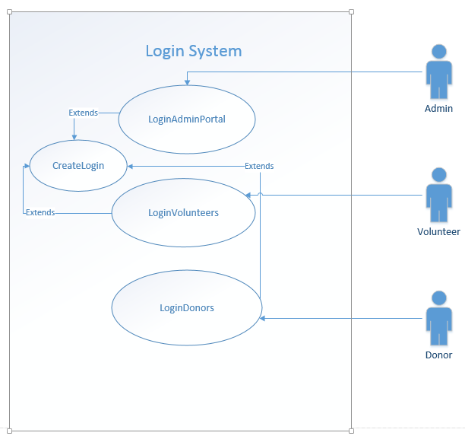

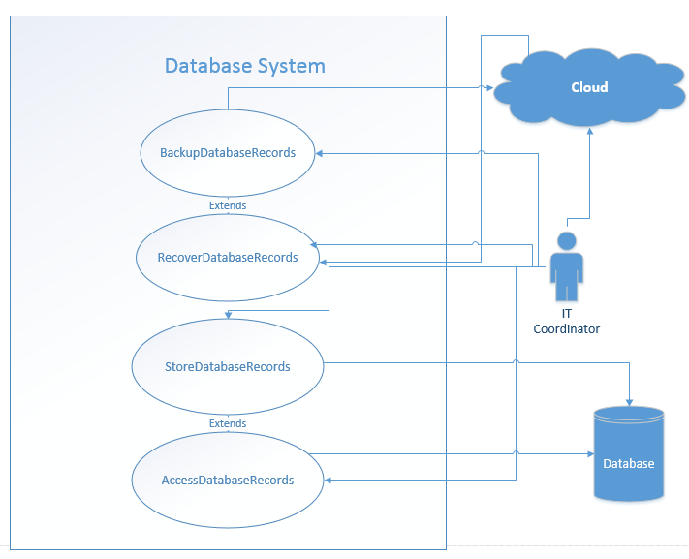

Login Prototype

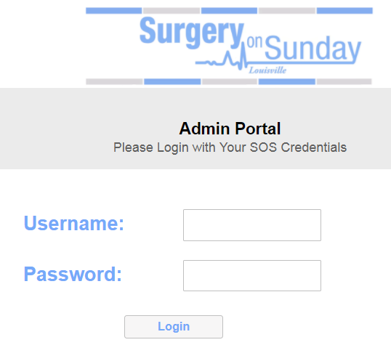

Class Diagrams

|  |  |
| --- | --- |
| IT Coordinator | Admin |
| Attributes: -Username  -Password | Attributes: -Username  -Password |
| Methods: -Enter(Username)  -Enter(Password)  -Submit(Username, Password)  -Enter(Queries)  -Execute(Queries)  -RetrieveData() | Methods: -Enter(Username)  -Enter(Password)  -Submit(Username, Password) |
| For use cases:  AccessDatabaseRecords, RecoverDatabaseRecords,  BackupDatabaseRecords,  StoreDatabaseRecords | For use case:  LoginAdminPortal |
| Volunteer | Donor |
| Attributes: -Username  -Password | Attributes: -Username  -Password |
| Methods: -Enter(Username)  -Enter(Password)  -Submit(Username, Password) | Methods: -Enter(Username)  -Enter(Password)  -Submit(Username, Password) |
| For use cases:  LoginVolunteers | For use case:  LoginDonors |

The class diagrams below are related to the use cases mentioned in this document. In each case, the actor has to enter their username and password, which is stored as attributes of their class. They can perform certain actions (methods) as they interact with the system.

Sequence Diagrams

The remaining diagrams illustrate the steps taken behind the scenes for the use case to be carried out. The actor fills out and submits fields associated with their class and the object-oriented code communicates with the database or cloud. Then, feedback is provided to the program which gives visual feedback to the user.

AccessDatabaseRecords

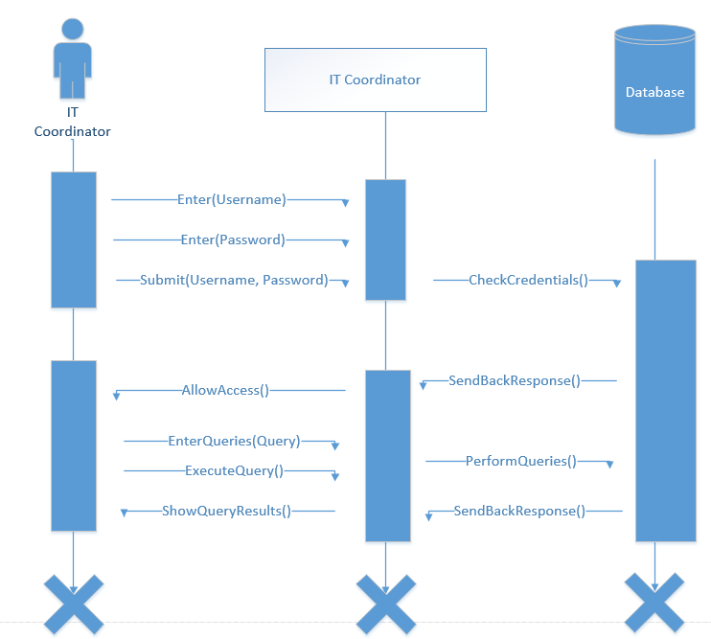

StoreDatabaseRecords

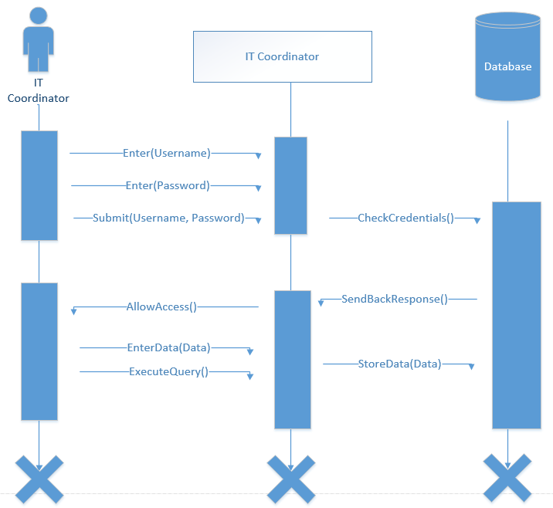

RecoverDatabaseRecords

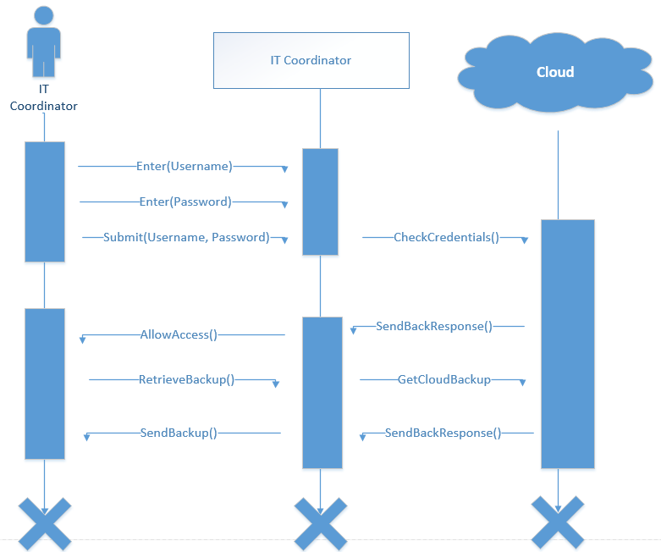

BackupDatabaseRecords

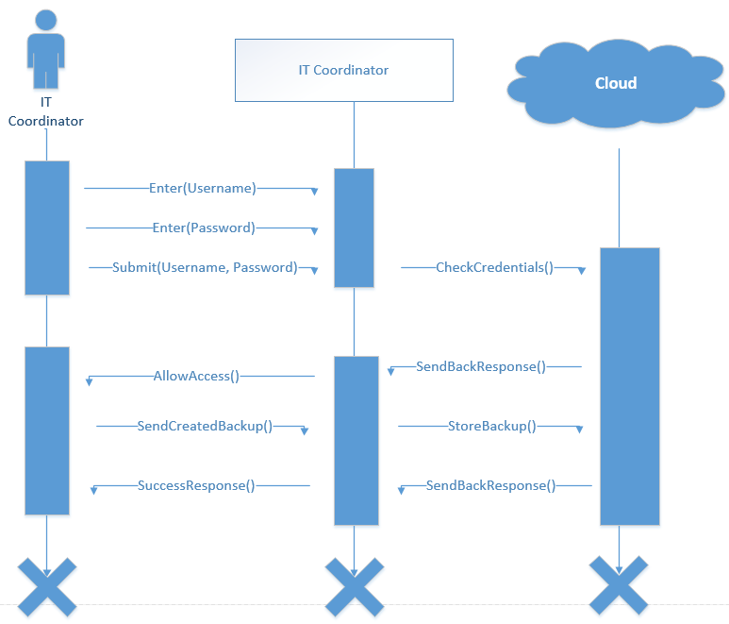

LoginAdminPortal

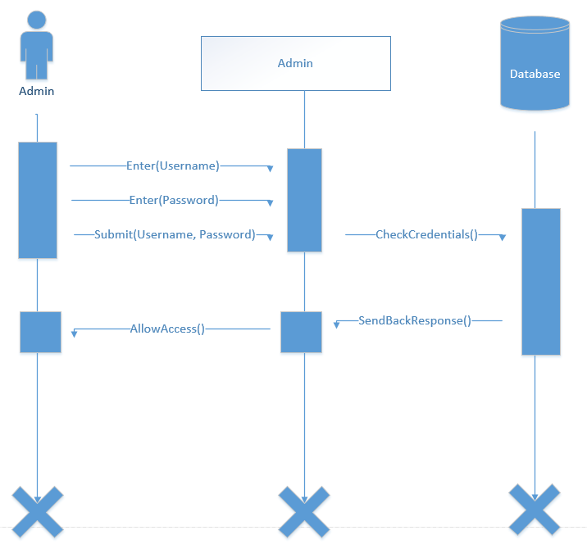

LoginVolunteers

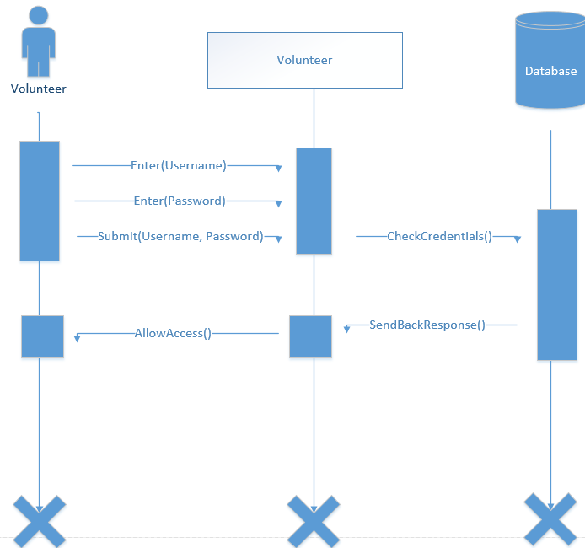

LoginDonors

